**Project Analysis - Hotel Reservation Program**

**Jules Torres, Megan Moore, Mario Bethancourt**

**CMSC 495**

**Section 7380**

**Group 8:**

**11/07/2023**

**Professor Hung Dao**

**Revision History**

| **Date** | **Description** | **Author** |
| --- | --- | --- |
| 11/2/2023 | First Draft | Mario Bethancourt |
| 11/5/2023 | Revision | Jules Torres |
| 11/7/2023 | Final revision | Everyone |
| 11/12/2023 | Peer review analysis | Megan Moore |
| 11/14/2023 | Updates to data processing steps | Megan Moore |
| 12/09/2023 | Made final updates | Mario Bethancourt |

**Project Analysis:**

The goal of this project is to create a Java program used to make hotel reservations. The application will be designed for use in individual client devices. This analysis will go over various aspects of the project such as input data, output data, sources of output data, the destinations of output data, how the user inputs are converted into output data, and subsystems. The purpose of the analysis is to assess the system's performance, ensuring it functions as intended.

The table below contains the requirements and description for this system. The table is for reference and convenience purposes.

| **Requirement #** | **Description** |
| --- | --- |
| 1 | This system shall allow users to create accounts, with a unique username password required. |
| 2 | This system shall store personal data such as first name, last name, username, password, phone number and address(street number and street name), email, state, city, and zip code for registered users. |
| 3 | This system shall provide users with the capability to view a list of available room reservations. |
| 4 | This system shall allow users to create new reservations only when logged in. |
| 5 | The system shall allow users to perform check-in and check-out operations. So, checking in and checking out, giving an ID when the user checks in, making a room available when the user checks out. |
| 6 | This system shall generate a bill for each reservation per night that the user plans on staying. |
| 7 | This system shall not automatically log users out due to inactivity; however, it shall allow users to exit or log-off manually. |
| 8 | This system shall show the user the list of room numbers with their description when making a reservation. The list displays rooms with their room number, number of beds and room type (room 101, room 102, single, double, deluxe, suite, single or double bed). |
| 9 | This system shall enable users to select specific rooms by entering the room number from the room list. The user can start making a reservation by picking the room number (101, 102, 103, etc.). |
| 10 | This system shall allow users to input check-in and check-out dates along with the desired number of people when making a reservation. So, when the user picks the room number when making a reservation they are asked for the check in/out dates and number of people staying. |
| 11 | This system shall support account update changes, allowing users to input specific account changes making modifications such as first name, last name, username, password, phone number and address(street number and street name), email, state, city, and zip code. |
| 12 | This system shall provide an option for users to delete reservations. Users shall input the specific reservation by room number (101, 102, 103, etc.) to be deleted, and the system will display a cancellation confirmation. |

**Project Analysis Questions**

A hotel reservation system typically collects and processes various types of data to facilitate the booking and management of hotel rooms.

**What is the input data?**

The input data in a hotel reservation system can include, guest information, system user’s login information, reservation details, and payment information. The hotel reservation system uses input data to manage room inventory, process payments, generate confirmations, and provide necessary information to hotel staff for a smooth check-in and check-out process. Additionally, the data collected is often stored for record-keeping, analytics, and customer relationship management purposes. It's important for hotel reservation systems to handle this data securely and in compliance with privacy regulations.

**What are the sources of input data?**

Hotel guest information, which includes their name, how many guests and their name, contact details such as phone number, email address, and their payment information. The payment information will include their credit card details and billing address. The reservation details will include the check-in date and time, and the check- out information.

**What is the output data?**

The output data from a hotel reservation system encompasses various information generated as a result of processing input data and managing reservations. Some of the key elements of output data in a hotel reservation system is booking confirmations of the reservations, reservation details, lists of available reservations, invoices, and customer confirmations.

**What are the destinations of output data?**

The output data from the hotel reservation system is crucial for providing a seamless experience for guests, managing hotel operations efficiently, and analyzing performance for future improvements. Many of the output data such as the hotel guests and system user’s personal information is sent to a database, reservation confirmations are sent to guests under their listed form of contact such as their email, lists or reservations displayed on the user’s system, bills sent to the user’s profile, check-in/check-out confirmations sent to the guests. Records of communication with guests, including emails, messages, or phone calls related to their reservation. Data logs for compliance purposes and audit trails to track changes made in the system.

**Data Flow:**

Input Subsystem initializes foundational data.

Account Management Subsystem manages user data and reservations.

Room Reservation Subsystem tracks room availability.

Session Management Subsystem orchestrates user interactions, pulling data from other subsystems.

Reservation Management Subsystem handles the details of individual reservations, interacting closely with the Account Management Subsystem.

**How do we convert the input data into output data?**

Converting input data into output data in a hotel system involves implementing various functionalities to process reservations, manage guest information, and generate relevant outputs.

The Hotel Reservation Program will be using a Graphical User Interface (GUI) as a visual way for users to interact with the program.

In the context of software development, a Graphical User Interface (GUI) is a visual way for users to interact with a computer program. The GUI process involves several key components and steps:

1. **User Interaction:** The GUI allows users to interact with the hotel application using visual elements such as buttons, menus, text boxes, and other graphical components. The users will input their information as listed above.
2. **Event Handling:** When a user interacts with the GUI, events are generated. Event handling is the process of capturing and responding to these events.
3. **Information Processing:** When a user inputs information, the GUI processes the data. This processing can include validation, formatting, and other operations depending on the nature of the input. The information is then typically passed to the underlying application for further processing.
4. **Communication with Application Logic:** The GUI communicates with the underlying application logic or business logic. This logic performs the necessary operations based on the user's input.The application logic may involve complex calculations, data retrieval from databases, or other operations depending on the software's purpose.
5. **Data Display:** The GUI is responsible for displaying processed information to the user. This includes presenting results, showing feedback messages, and updating the user interface to reflect the current state of the application.Information can be displayed in various formats, such as text, images, tables and charts.
6. **Feedback to the User:** The GUI provides feedback to the user based on the outcome of their actions. This feedback can be in the form of success messages, error messages, or visual cues to indicate the status of a process.

**Project Data**

1. **Outside system:** The term "outside system" refers to any external systems or components that interact with the hotel program and are not part of its internal architecture. These external systems may exchange data with the hotel system to enhance functionality, provide additional services, or integrate with other software. Some of the outside system users will be the hotel guest, hotel system user, payment gateways, customer relationship management systems (CRM) that store and manage guest information, preferences, and communication history.
2. **Input data:** User personal information(name, contact details), log in information( username and password), reservation details(check in and check out dates, room type), and payment information. The input data originates from the guest’s preferences and personal information.
3. **Output data:** Confirmation of the reservations, reservation details, lists of available reservations, invoices, and customer confirmations. The output data will be sent back to the user as a confirmation, this data is stored in a database.
4. **Data processing:** Data processing tasks contribute to the efficient operation of the hotel reservation program, ensuring a smooth booking process for guests and effective management of hotel resources. Examples of key data processing in the application:

* Reservation Creation: Collect and process guest information.
* Check room availability based on specified dates and room preferences.
* Generate a unique reservation number.
* Record reservation details, including check-in and check-out dates, room type, and any special requests.
* Update the availability of rooms in real-time based on reservations and cancellations.
* Validate guest information and identification.
* Calculate the total cost of the reservation, including room rates, taxes, and any additional charges.
* Process payments securely, handling different payment methods. Generate invoices or receipts.
* Handle reservation cancellations and modifications.
* Maintain a database of guest profiles, including contact information, preferences, and history of previous stays.

The context diagram is shown in Figure 1. This diagram shows the input, and output data.

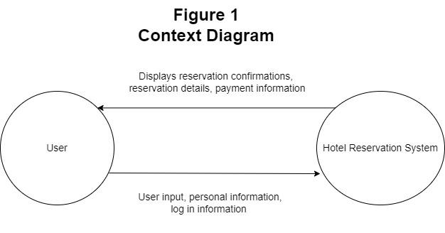

**Subsystems**

The system contains the following subsystems: Input, Account Management, Room Reservation, Session Management, Reservation Management. The subsystem diagram in figure 2 shows the relationship between each subsystem.

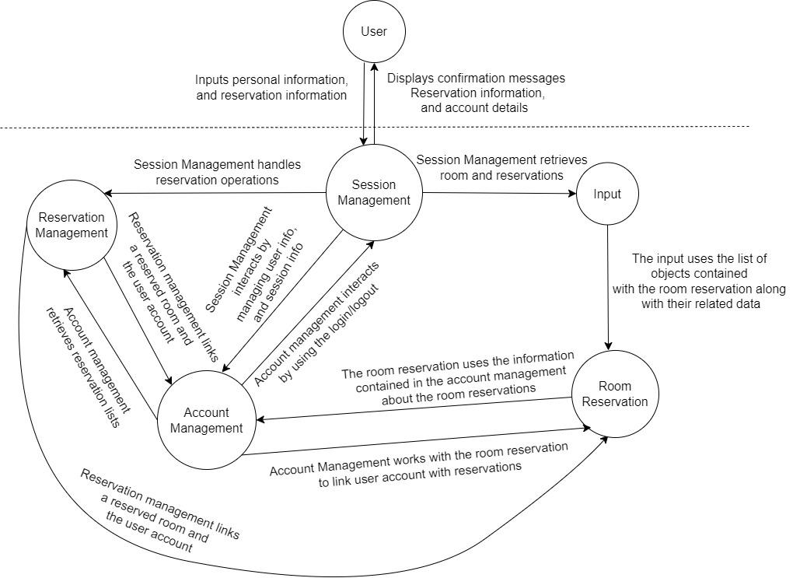

**Subsystem descriptions**

* Input subsystems: This subsystem is responsible for initializing and managing the underlying data structures for the hotel reservation system. It creates and maintains a collection of RoomReservation objects representing the available rooms in the hotel. Additionally, it manages the input data relevant to the hotel, such as the hotel name and the number of floors. The Input class provides a foundation for the hotel reservation system by organizing and handling essential data structures and information.
* Account management subsystem: This subsystem represents user accounts within the hotel reservation system. It encapsulates user details such as name, contact information, and login credentials. Additionally, it manages reservations associated with each user, providing methods for updating user information and handling password verification. This class is integral to user authentication, account creation, and account updates, ensuring secure and accurate management of user data.
* Room Reservation subsystem: This subsystem represents individual hotel rooms, storing information about their occupancy status and associated reservations. It contains methods for occupying and vacating rooms, allowing for dynamic updates to room availability. This class is essential for tracking the status of each room, ensuring accurate information is displayed to users during the reservation process and in the main menu.
* Session management subsystem: This subsystem serves as the central control unit for managing user sessions in a hotel reservation system. It encapsulates the functionality for user authentication, handling reservations, updating user accounts, and managing check-in and check-out processes. This class orchestrates the user interface, using Swing components to display various panels and dialogs. It also interfaces with the underlying data structures and files to load and save user information, providing a comprehensive structure for managing user interactions within the hotel system.
* Reservation management subsystem: This subsystem models individual hotel room reservations, capturing details such as check-in and check-out dates, the number of occupants, and associated costs. It is closely tied to the AccountManagement class, linking reservations to specific users. This class facilitates the booking process, updates the availability of rooms, and calculates reservation costs. It plays a crucial role in maintaining a record of user reservations and their corresponding details.

The following table lists the subsystems that implement the requirements.

| **Requirement #** | **Subsystems** |
| --- | --- |
| 1 | Account Management, Session Management |
| 2 | Account Management |
| 3 | Input, Room Reservation |
| 4 | Session Management, Room Reservation |
| 5 | Session Management, Room Reservation |
| 6 | Room Reservation, Reservation Management |
| 7 | Session Management |
| 8 | Input, Room Reservation |
| 9 | Input, Room Reservation |
| 10 | Input, Room Reservation |
| 11 | Account Management |
| 12 | Reservation Management, Room Reservation |

**Possible enhancements:**

There are many enhancements that can be incorporated to the project with the primary focus on staff-related options.The staff can have more control of the reservation information, and database. This could keep the staff in mind when it comes to changes to the reservations and data access. Depending on their respective responsibilities, staff members can be assigned varying duties, including the ability to create, cancel, or update user reservations. Including this feature will lengthen the scope of the project.

**Other enhancements:**

* Adding user reviews. User reviews are a crucial aspect of a hotel reservation program, as they provide valuable insights for potential guests.
* User feedback options. It's important to gather feedback from users to continually improve the reservation program.
* Customer support. A responsive and efficient customer support system is crucial for ensuring a positive user experience.
* More room researching/filtering options such as specific amenities(WI-FI, pool, gym).

**Possible risk and risk mitigation:**

* Data security risk: Storing personal information requires robust data security. Currently we are storing user information on a text file which is not the most secure option. To mitigate this risk, we can implement a lockout system that limits the number of password attempts for users. Additionally, implementing encryption and industry-standard practices such as two factor verification, can enhance data protection.
* Data privacy risk: Customers may have concerns about the confidentiality of their personal information. Adding a privacy policy can reassure users of their safety and privacy.
* User error risk: Users may inadvertently delete a reservation. To mitigate this risk, we can introduce a confirmation step before allowing reservation deletions.

**Analysis Peer Review:**

Many suggestions were made in the peer review, the ones that have been taken into account are listed below and alterations have been made.

* Project Plan would benefit from a more detailed outline of the phases of development, including time allocations for each phase, risk assessment, and contingency plans.
* Project Requirements are comprehensive but lack some specifications, such as security protocols for data protection and potential integrations with other systems.
* Project Plan should provide more detail on the specific tasks and milestones, as well as define the criteria for moving from one phase to the next.